**Assignment 1: Linux Basics**

**Objective:**

This assignment demonstrates fundamental Linux command-line operations including file and directory management, viewing file contents, searching patterns, compressing and decompressing files, downloading files from the web, managing permissions, and working with environment variables. Each task is completed using core Linux commands and is essential for anyone pursuing system administration or DevOps roles.

**Task Overview:**

**1. Creating and Renaming Files/Directories**

* Created a directory named test_dir using mkdir.
* Created an empty file example.txt inside test_dir using touch.
* Renamed example.txt to renamed_example.txt using the mv command.

**2. Viewing File Contents**

* Used cat to display the full contents of /etc/passwd.

* Displayed the **first 5 lines** of /etc/passwd using head -n 5.
* Displayed the **last 5 lines** of /etc/passwd using tail -n 5.

**3. Searching for Patterns**

* Used grep "root" to find all occurrences of the word "root" within /etc/passwd.

**4. Zipping and Unzipping**

* Compressed the test_dir directory into a zip file named test_dir.zip using zip -r.
* Unzipped test_dir.zip into a new directory unzipped_dir using unzip.

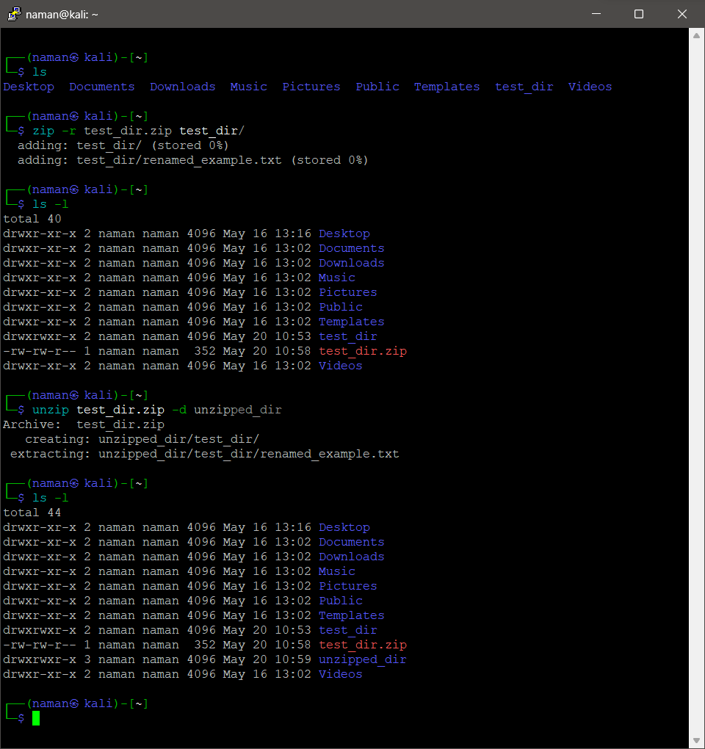

**5. Downloading Files**

* Downloaded a file using wget from a sample URL (https://github.com/trinib/Linux-Bash-Commands/blob/main/README.md).

**6. Changing Permissions**

* Created a file named secure.txt using touch.
* Modified its permission to **read-only** for all users using chmod 444 secure.txt.

**7. Working with Environment Variables**

* Set a new environment variable MY_VAR with the value "Hello, Linux!" using the export command.

